

**CLOUD COMPUTING – SWE4002**

**Project TITLE**

**DESIGN AND BUILD A WORDPRESS WEBSITE IN AMAZON WEB SERVICES (AWS) USING DIFFERENT SERVICES**

**SUBMITTED BY**

**P.V.M SAI VIHARI – 15MIS0417**

**M.Tech. Software Engineering (Integrated)**

*Under the guidance of*

**Prof. SIVA RAMA KRISHNAN S**

**Slot: C1**

**School of Information Technology and Engineering - SITE**

**ABSTRACT**

This systems tells about how to Create, Build, Design and Manage the WordPress website in Amazon web services (AWS) using different services like LightSail, VPC, Elastic Bean Stalk (EBS), Elastic Cloud Compute (EC2).

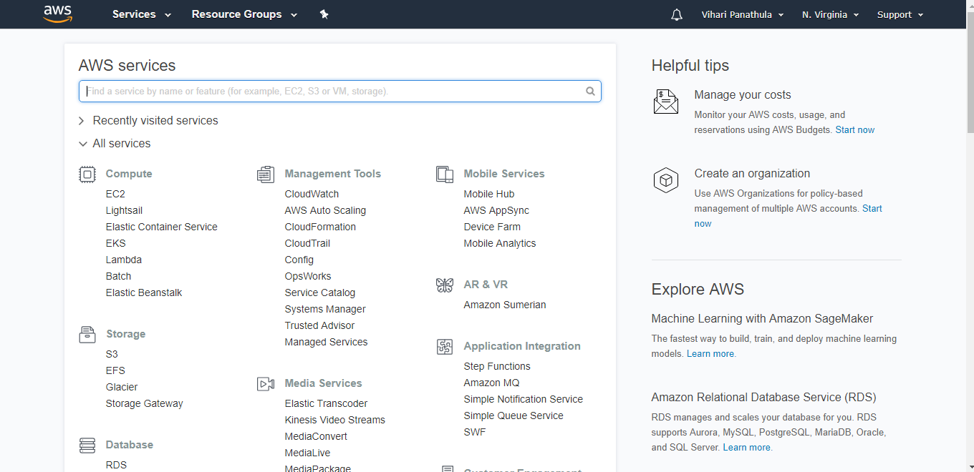

**Planning:**

As I said earlier, I am planning to do the word press website in Amazon web services.

The brief introduction of AWS is given below:

In 2006, Amazon Web Services (AWS) began offering IT infrastructure services to businesses in the form of web services—now commonly known as cloud computing. One of the key benefits of cloud computing is the opportunity to replace up-front capital infrastructure expenses with low variable costs that scale with your business. With the cloud, businesses no longer need to plan for and procure servers and other IT infrastructure weeks or months in advance. Instead, they can instantly spin up hundreds or thousands of servers in minutes and deliver results faster. Today, AWS provides a highly reliable, scalable, low-cost infrastructure platform in the cloud that powers hundreds of thousands of businesses in 190 countries around the world.

The Amazon Web Services (AWS) Cloud provides a broad set of infrastructure services, such as computing power, storage options, networking and databases that are delivered as a utility: on-demand, available in seconds, with pay-as-you-go pricing. From data warehousing to deployment tools, directories to content delivery, over 90 AWS services are available. New services can be provisioned quickly, without upfront capital expense. This allows enterprises, start-ups, small and medium-sized businesses, and customers in the public sector to access the building blocks they need to respond quickly to changing business requirements.

**Expected outcome:**

WordPress is an Open Source Content Management System (CMS) which makes the entire process of designing, creating, updating and maintaining a website or a Blog simple. Over the years WordPress Development has evolved into much more than a CMS and into a utility which lot of companies as well as individuals are taking benefit off.

WordPress is easy to use. Once you get your business Website completely developed from an agency, you can easily add, modify or delete content yourself whenever needed. There are numerous of plugins available in WordPress to add unique or simple functionality to your business websites. There are many custom plug-ins also available in WordPress.

Our main aim is to create a website using AWS platform for the digital marketing not only for the Digital marketing any other business related stuff.

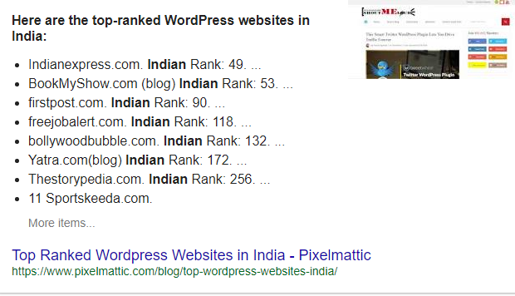

**INTRODUCTION**

**Problem Statement:**

Now a days each and every person is using the websites in our day to day life.

Normal websites usually, it costs around $2,000 to $25,000 to hire a web developer, who designs a custom HTML website. Add the yearly hosting fees and maintenance fees to that and you’ll end up spending your entire marketing budget on building your website.

Maintaining a Normal or regular website involves a lot of work. You have to keep your website up to the latest standards, optimize it for mobile devices, implement good security to prevent hacker attacks and more important, adding new pages and content to your website.

So, to overcome these issues I am, developing or building a WordPress in Amazon web services which makes easier and secure than anything.

**Motivation:**

WordPress is an Open Source Content Management System (CMS) which makes the entire process of designing, creating, updating and maintaining a website or a Blog simple. Over the years WordPress Development has evolved into much more than a CMS and into a utility which lot of companies as well as individuals are taking benefit off.

WordPress is easy to use. Once you get your business Website completely developed from an agency, you can easily add, modify or delete content yourself whenever needed. There are numerous of plugins available in WordPress to add unique or simple functionality to your business websites. There are many custom plug-ins also available in WordPress.

One of the main reasons why people love WordPress is that the platform gives you access to thousands of beautiful WordPress themes to build any type of website you want. For example, let’s say that you’re planning on building a niche website, like a site for a construction company or a beauty salon. Then you can easily find a WordPress theme in the Internet we have to just download it and apply theme.

**Why WordPress in AWS platform?**

**Easy to use**

AWS is designed to allow application providers, ISVs, and vendors to quickly and securely host your applications – whether an existing application or a new SaaS-based application. You can use the AWS Management Console or well-documented web services APIs to access AWS’s application hosting platform.

**Flexible**

AWS enables you to select the operating system, programming language, web application platform, database, and other services you need. With AWS, you receive a virtual environment that lets you load the software and services your application requires. This eases the migration process for existing applications while preserving options for building new solutions.

**Cost-Effective**

You pay only for the compute power, storage, and other resources you use, with no long-term contracts or up-front commitments. For more information on comparing the costs of other hosting alternatives with AWS, see the AWS Economics Center.

**Reliable**

With AWS, you take advantage of a scalable, reliable, and secure global computing infrastructure, the virtual backbone of Amazon.com’s multi-billion dollar online business that has been honed for over a decade.

**Scalable and high-performance**

Using AWS tools, Auto Scaling, and Elastic Load Balancing, your application can scale up or down based on demand. Backed by Amazon’s massive infrastructure, you have access to compute and storage resources when you need them.

**Secure.**

AWS utilizes an end-to-end approach to secure and harden our infrastructure, including physical, operational, and software measures. For more information, see the AWS Security Center

**OBJECTIVE:**

The main objective of the system is to implement the WordPress website in the Amazon web services. Most of the people just downloading the WordPress application from the WordPress website, do not have the backup of the website files such as Photos, Videos, and Text files, and mainly security issues are incorporated while hosting the website. To overcome these issues I have implemented the WordPress website in the Amazon web services.

**Proposed System:**

The main objective of the proposed system is to implement the WordPress in the Amazon web services. Because, AWS consists of lot of services which makes our work easier to deploy and host the website. Now a days many of people doing the coding for the websites this is the coding less system which makes our work easy. After deploying the website in the Amazon web services we can just add Themes, Plugins and many more to design the website.

**Advantages of the Proposed System:**

**The main advantages of this proposed system is:**

* Save A Ton Of Money.
* Cut Out The Middleman
* The Ability To Scale The Website With Plugins
* Setup Your Website Within Five Minutes
* Increase speed and agility in AWS.
* Go global in minutes in AWS.
* Security and hosting in AWS.

**SYSTEM DESIGN**

**System Architecture:**

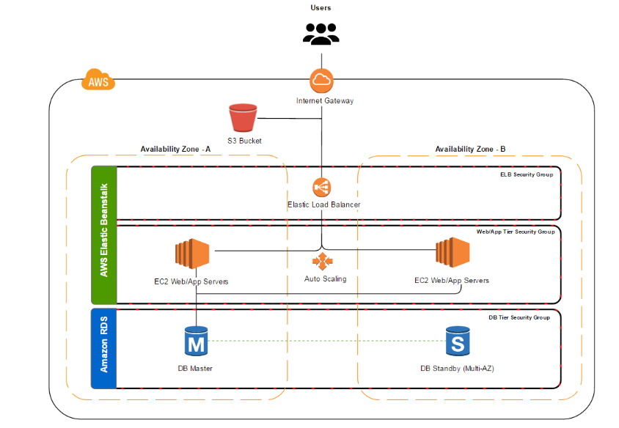

**Module Description:**

We have seven modules to discuss in the Amazon Web Services to host a website such as,

**Amazon S3:** Amazon S3 provides secure, durable, and highly-scalable cloud storage for the objects that make up your WordPress website. Examples of objects you can store include media libraries, theme files, images, videos, and JavaScript. Amazon S3 makes it is easy to use object storage with a simple web interface to store and retrieve data from anywhere on the web, meaning that your website will be reliably available to all your visitors.

**Amazon EC2:**  Amazon EC2 provides the virtual application servers, known as *instances*, to host your WordPress website. Amazon EC2 allows you to configure and scale your compute capacity easily to meet changing requirements and demand. It is integrated with Amazon’s proven computing environment, allowing you to leverage the AWS suite of services.

**Amazon RDS:** Amazon RDS provides managed relational databases environments, known as *instances*, in the AWS cloud. DB instances provide cost-efficient and resizable capacity while managing time-consuming database administration tasks, freeing you up to focus on your WordPress application. While this project will use a MySQL-configured DB instance, Amazon RDS is also compatible with Amazon Aurora, Oracle, Microsoft SQL Server, PostgreSQL, and Maria DB.

**Elastic Load Balancing:** An Elastic Load Balancing load balancer distributes requests to the EC2 instances running your WordPress website. This allows you to achieve greater levels of fault tolerance in your application, seamlessly providing the required amount of load balancing capacity needed to distribute application traffic.

**Auto Scaling:** The Auto Scaling service ensures that your WordPress environment is optimized for availability.  You can set a minimum number of available application servers and can add or remove application servers as demand on your WordPress website or blog changes.

**AWS Elastic Beanstalk:** AWS Elastic Beanstalk is an easy-to-use service for deploying and scaling your WordPress website onto the AWS platform. Elastic Beanstalk handles the details of your hosting environment, including provisioning AWS resources such as EC2 application servers, and configuring load balancing, scaling, and monitoring.

**Amazon LightSail:** Amazon LightSail is the easiest way to get started with AWS if you just need virtual private servers. LightSail includes everything you need to launch your project quickly – a virtual machine, SSD-based storage, data transfer, DNS management, and a static IP – for a low, predictable price. After you create your instance, you can easily connect to it. You can manage your instances using the LightSail console, LightSail API, or LightSail command line interface (CLI).

**WordPress:** In this WordPress we have to just create the username and password by using the amazon web services and then we can design the website by install plugins and themes.

**System Specification:**

Here, I am specifying the software and hardware requirements which is used in my project.

**Software Requirements:**

Operating system: Windows or Linux.

Technology: Amazon web services and WordPress.

Services used: Elastic Beanstalk, Load balancer, Amazon RDS, Amazon S3, EC2.

**Hardware Requirements:**

4 GB RAM

1 TB Hard Disk

2.0 GHZ Processor

**Detailed Design:**

**Use case Diagram:**

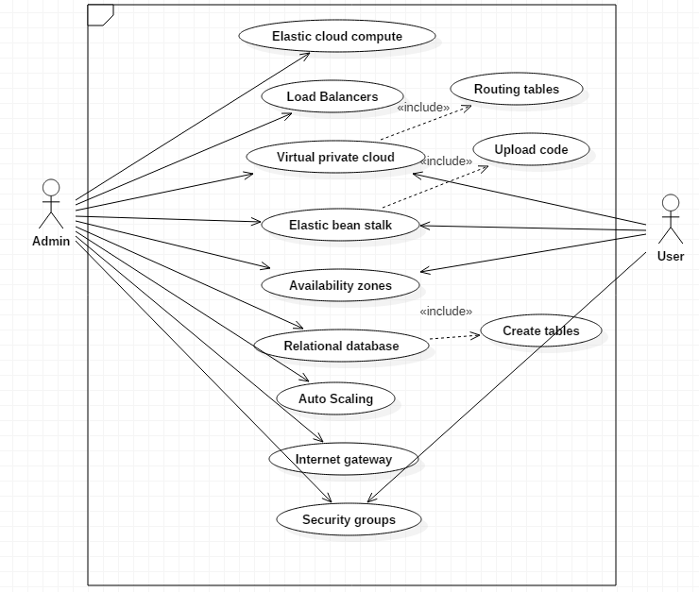

**Sequence Diagram:**

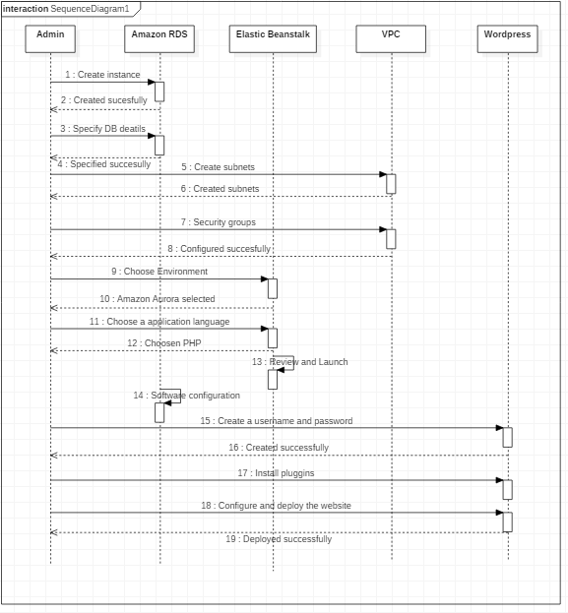

**Class Diagram:**

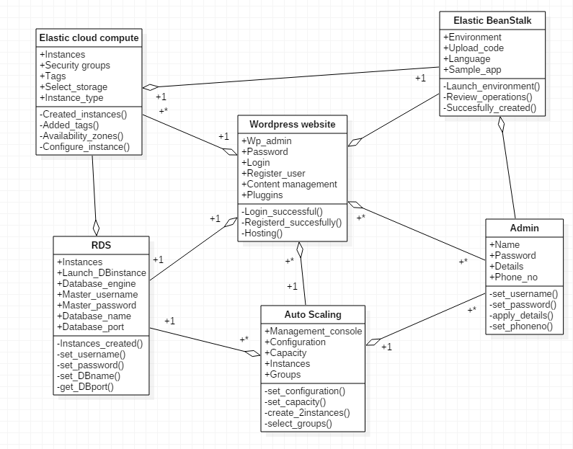

**Dataflow diagram:**

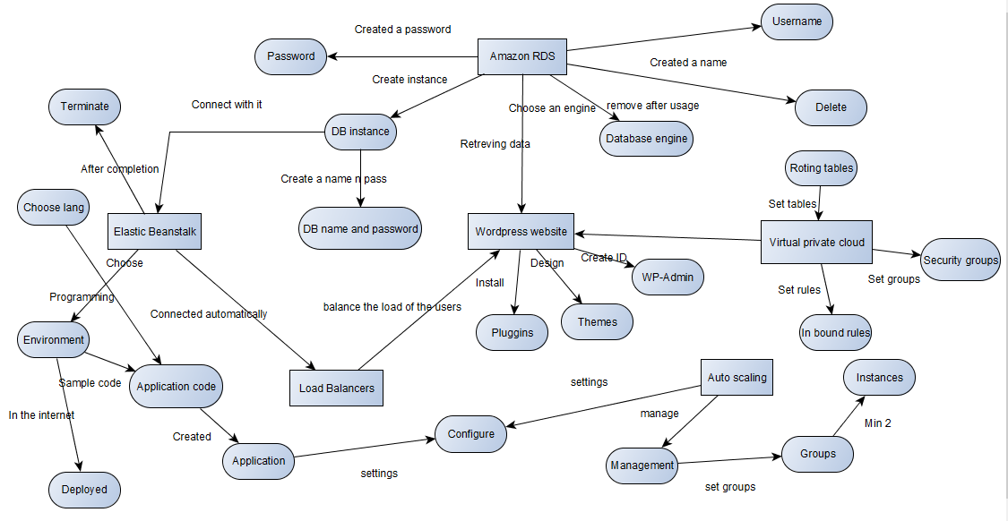

**Activity diagram:**

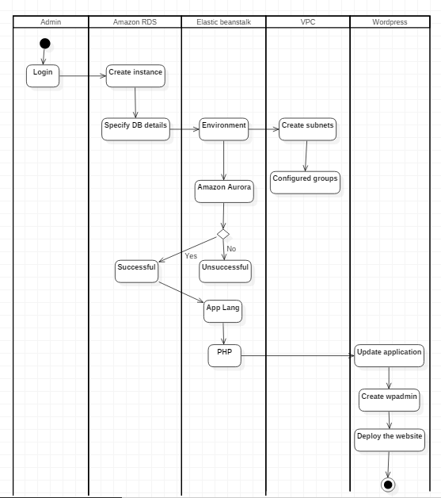

**IMPLEMENTATION**

Here I have implemented the WordPress website in the Amazon web services.

Amazon is the best platform to deploy the WordPress application because it can handle major security issues in hacking. Many services can be used in the AWS which ever we need. By using the AWS console our work will be very fast and it reduces the work but Amazon is pay-as-per use i.e. How much amount of services we using depends on time, Hardware and software requirements. For that time itself we have to pay for the Amazon. It is user Friendly.

AWS Documented material is enough to do this project and make the project successful.

This project describes how you launch an Amazon RDS DB instance that is external to AWS Elastic Beanstalk. Then it describes how to configure a high-availability environment running a WordPress website to connect to it. Running a DB instance external to Elastic Beanstalk decouples the database from the lifecycle of your environment. This lets you connect to the same database from multiple environments, swap out one database for another, or perform a blue/green deployment without affecting your database.

**Amazon S3:** Amazon S3 provides secure, durable, and highly-scalable cloud storage for the objects that make up your WordPress website. Examples of objects you can store include media libraries, theme files, images, videos, and JavaScript. Amazon S3 makes it is easy to use object storage with a simple web interface to store and retrieve data from anywhere on the web, meaning that your website will be reliably available to all your visitors.

**Amazon EC2:**  Amazon EC2 provides the virtual application servers, known as *instances*, to host your WordPress website. Amazon EC2 allows you to configure and scale your compute capacity easily to meet changing requirements and demand. It is integrated with Amazon’s proven computing environment, allowing you to leverage the AWS suite of services.

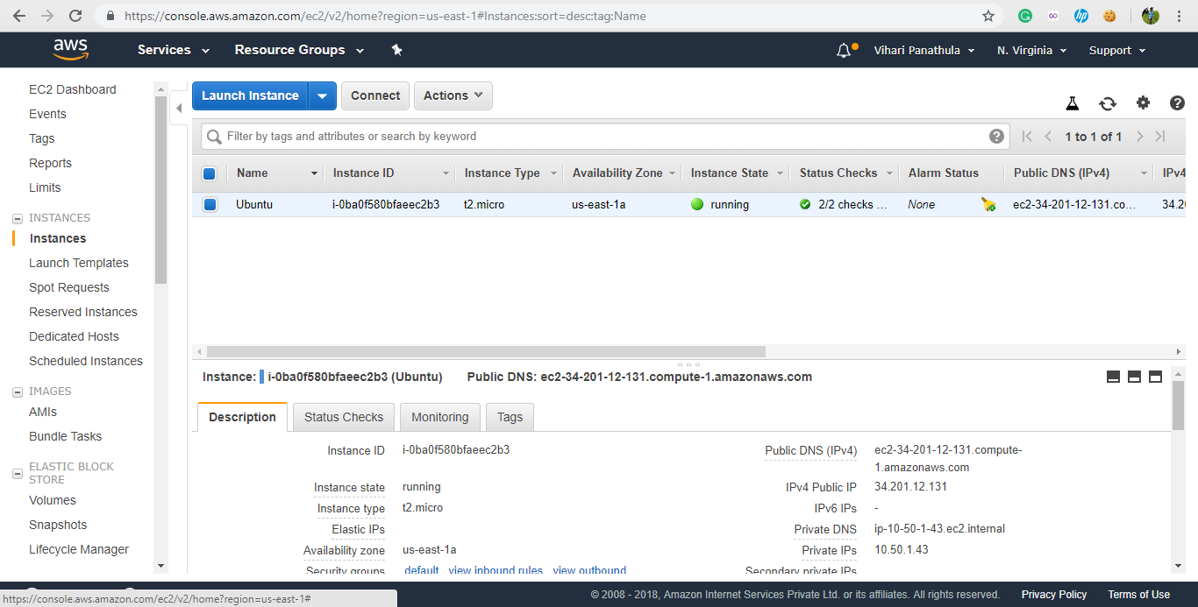

**Amazon RDS:** Amazon RDS provides managed relational databases environments, known as instances, in the AWS cloud. DB instances provide cost-efficient and resizable capacity while managing time-consuming database administration tasks, freeing you up to focus on your WordPress application. While this project will use a MySQL-configured DB instance, Amazon RDS is also compatible with Amazon Aurora, Oracle, Microsoft SQL Server, PostgreSQL, and Maria DB.

**Process to be done in Amazon RDS:** To use an external database with an application running in Elastic Beanstalk, first launch a DB instance with Amazon RDS. When you launch an instance with Amazon RDS, it is completely independent of Elastic Beanstalk and your Elastic Beanstalk environments, and will not be terminated or monitored by Elastic Beanstalk.

Use the Amazon RDS console to launch a Multi-AZ **MySQL** DB instance. Choosing a Multi-AZ deployment ensures that your database will fail over and continue to be available if the master DB instance goes out of service.

Modify the security group attached to your DB instance to allow inbound traffic on the appropriate port. This is the same security group that you will attach to your Elastic Beanstalk environment later, so the rule that you add will grant ingress permission to other resources in the same security group.

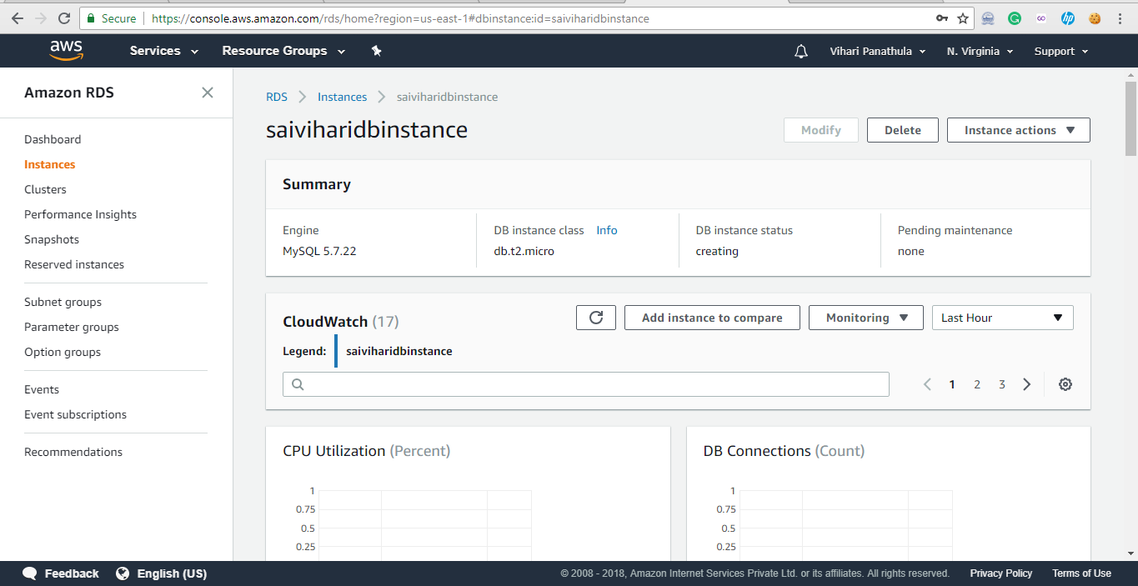

**Elastic Load Balancing:** An Elastic Load Balancing load balancer distributes requests to the EC2 instances running your WordPress website. This allows you to achieve greater levels of fault tolerance in your application, seamlessly providing the required amount of load balancing capacity needed to distribute application traffic.

**AWS Elastic Beanstalk:** AWS Elastic Beanstalk is an easy-to-use service for deploying and scaling your WordPress website onto the AWS platform. Elastic Beanstalk handles the details of your hosting environment, including provisioning AWS resources such as EC2 application servers, and configuring load balancing, scaling, and monitoring.

**Process to be done in Elastic Beanstalk:** Use the AWS Management Console to create an Elastic Beanstalk environment. Choose the PHP platform and accept the default settings and sample code. After you launch the environment, you can configure the environment to connect to the database, then deploy the WordPress code to the environment.

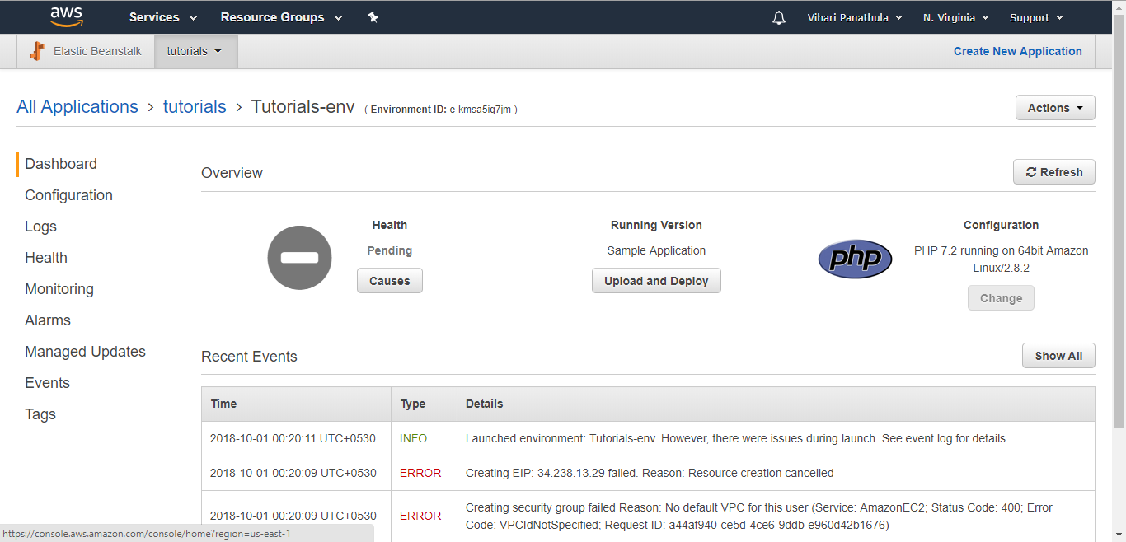

**Auto Scaling:** The Auto Scaling service ensures that your WordPress environment is optimized for availability.  You can set a minimum number of available application servers and can add or remove application servers as demand on your WordPress website or blog changes.

**Process to be done in Auto Scaling:** Finally, configure your environment's Auto Scaling group with a higher minimum instance count. Run at least two instances at all times to prevent the web servers in your environment from being a single point of failure. This also allows you to deploy changes without taking your site out of service.

**Amazon LightSail:** Amazon LightSail is the easiest way to get started with AWS if you just need virtual private servers. LightSail includes everything you need to launch your project quickly – a virtual machine, SSD-based storage, data transfer, DNS management, and a static IP – for a low, predictable price. After you create your instance, you can easily connect to it. You can manage your instances using the LightSail console, LightSail API, or LightSail command line interface (CLI).

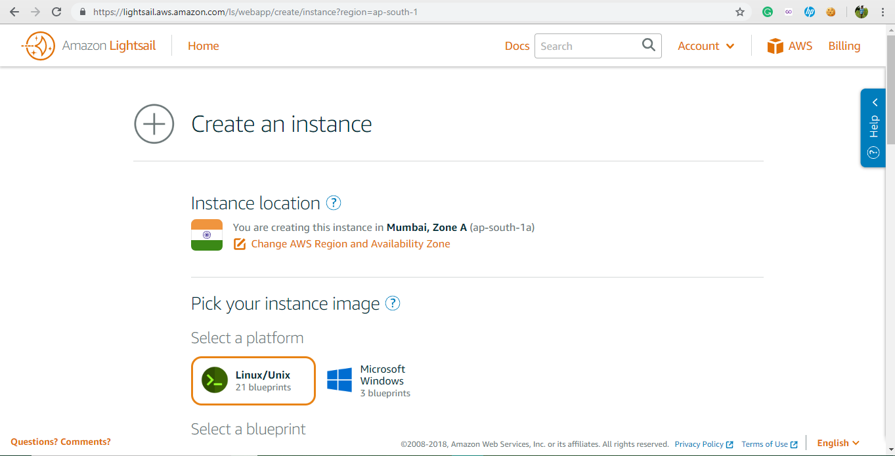

**CREATING A VPC AND CONNECTING TO EC2 INSTANCE**

**Step-1:** Go to services >> Click on Networking and content Delivery >> Click on VPC (Virtual private cloud.

**Step -2:** Go to your **VPC’S** in the Dash board.

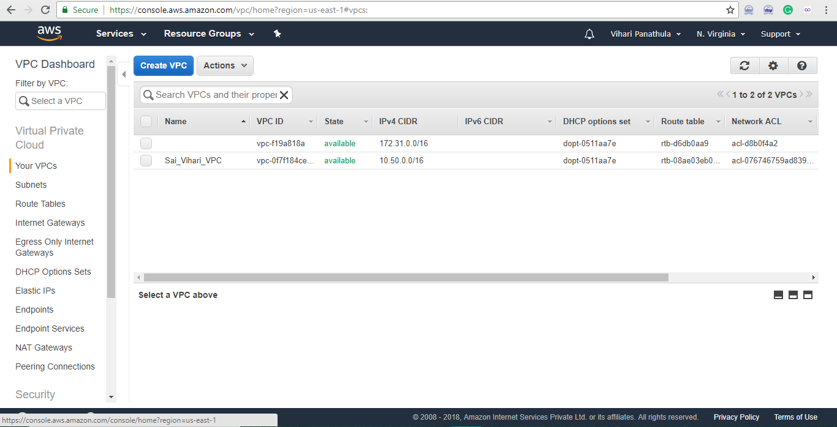

**Step-3:** Click on create **VPC**

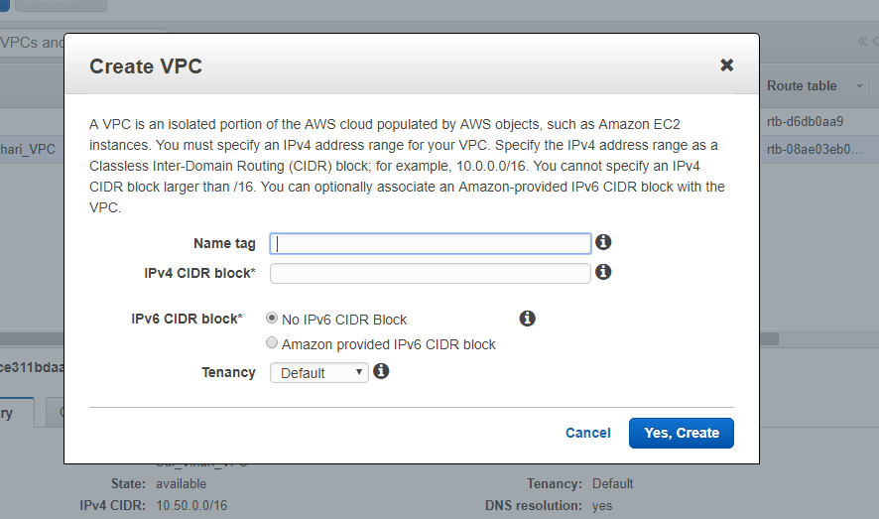

* Fill the name tag column with your own name.
* Fill the second column (IPV4 CIDR block ) as - 10.50.0.0/16
* Now Click Create button.
* Now your VPC has created

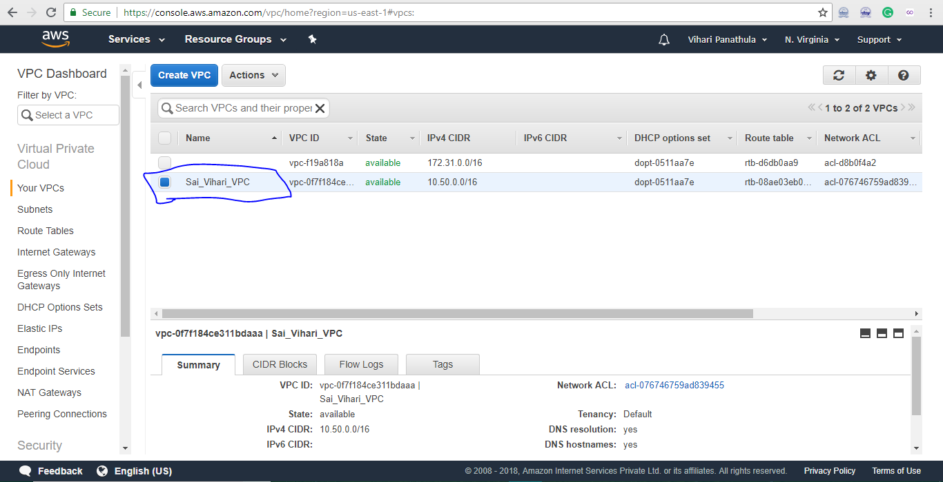

**VPC CREATED SUCCESFULLY**

**Step 4:** Click on the actions button and click the **Edit Host Names**

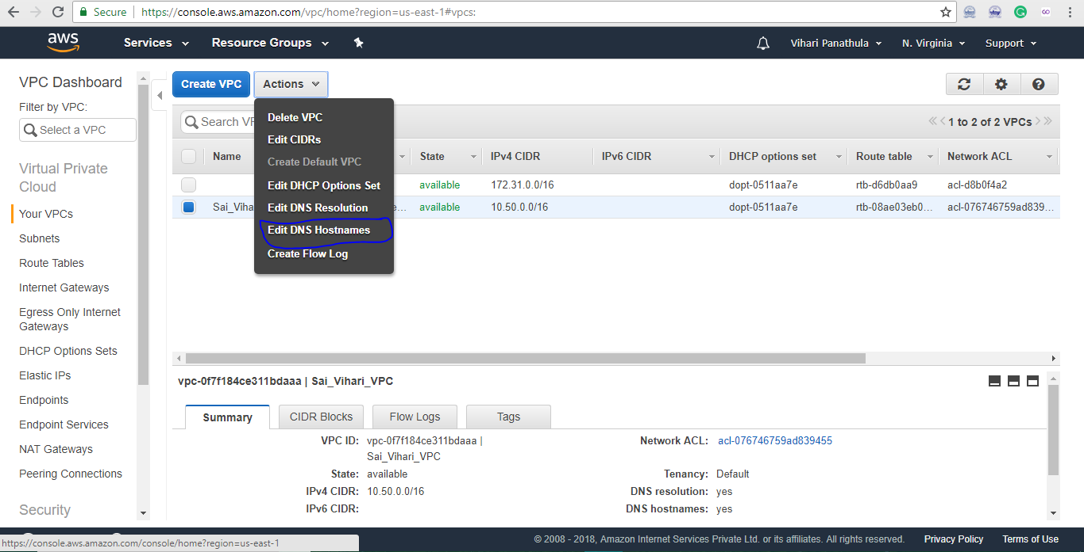

Intially the **DNS Hostnames** in “no” option change it to “Yes” and click save button to save the hostname.

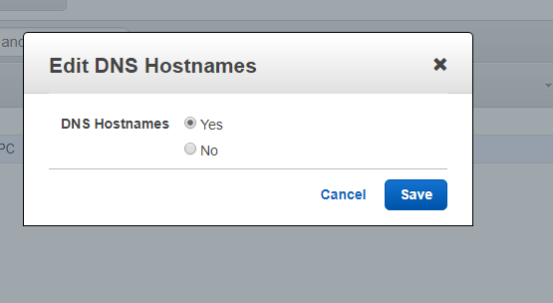

**Step-5 :** Go to Dashboard and click on the **Subnets.**

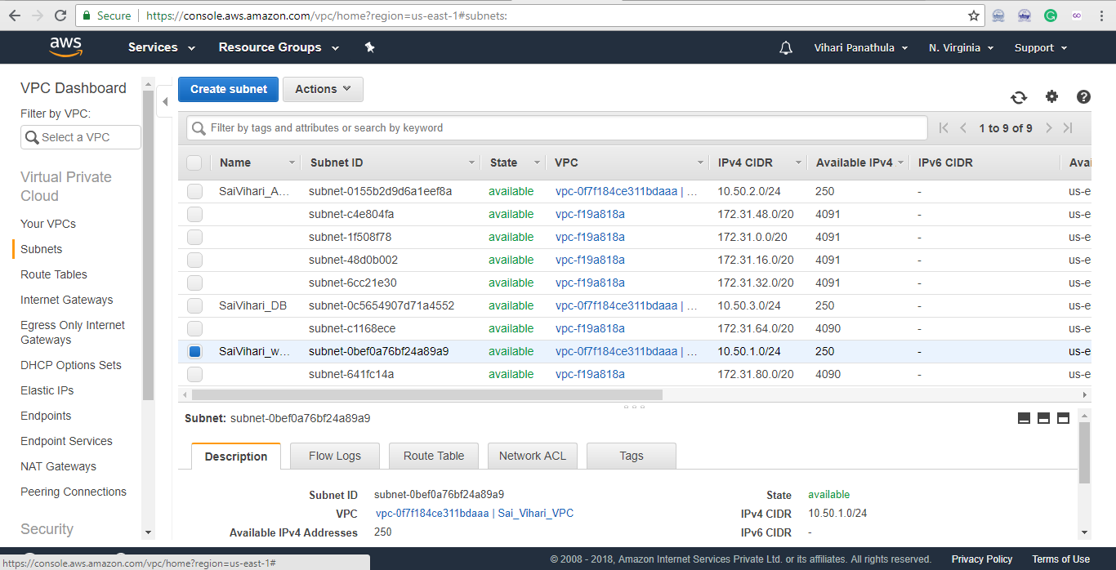

**Step-6 :** Create a **Subnet.**

* Add the tag name.
* In VPC Section select your own VPC ( Created before).
* Availability zone – Click which ever availability zone you need. For ex: us-east1a.
* IPV4 CIDR Block **- 10.50.1.0/24**
* At last click create.
* Then your subnet is created.

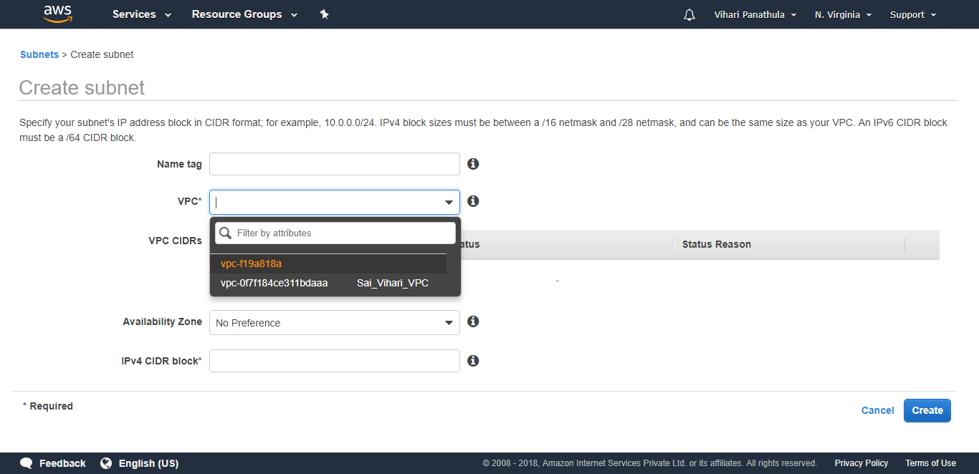

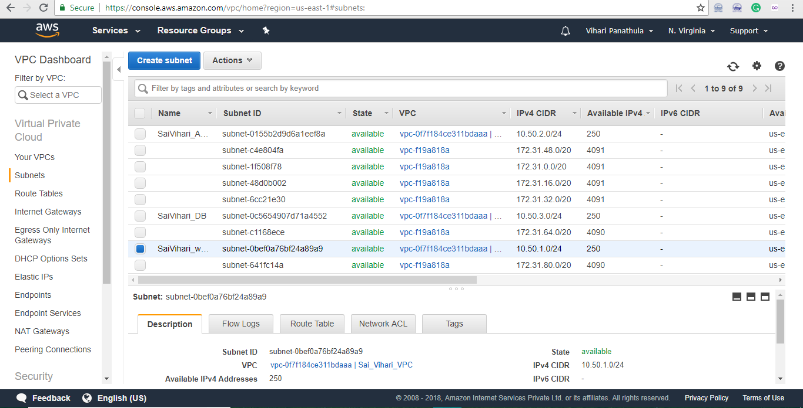

**Subnet Created successfully**

**Step-7 :** Like wise we have create **2 more subnets** with **different availability zones** and **different IPV4 addresses.**

* IPV4 ADDRESS 2- 10.50.2.0/24
* IPV4 ADDRESS 3 - 10.50.3.0/24

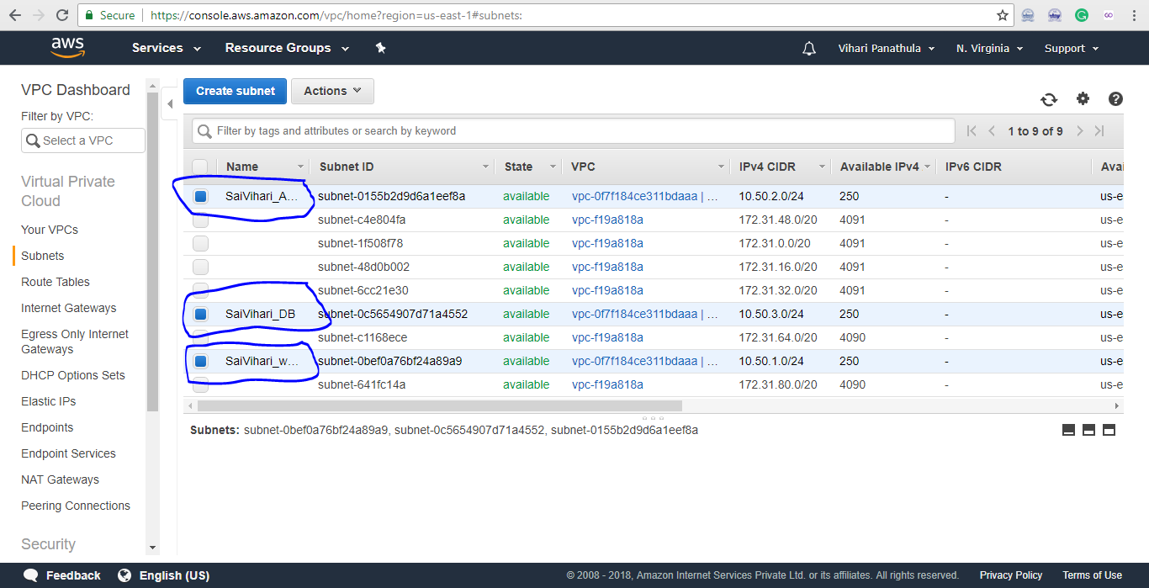

**Created 3 Subnets**

**Step-8 :** Right click on any subnet then **Modify auto- assign IP Settings** (Enable that settings>>click save)

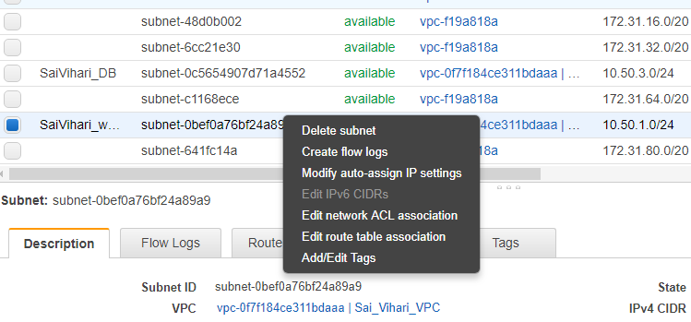

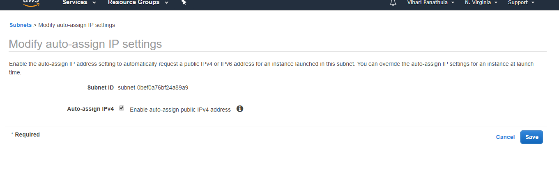**Step-9 :** Create an Internet Gateway

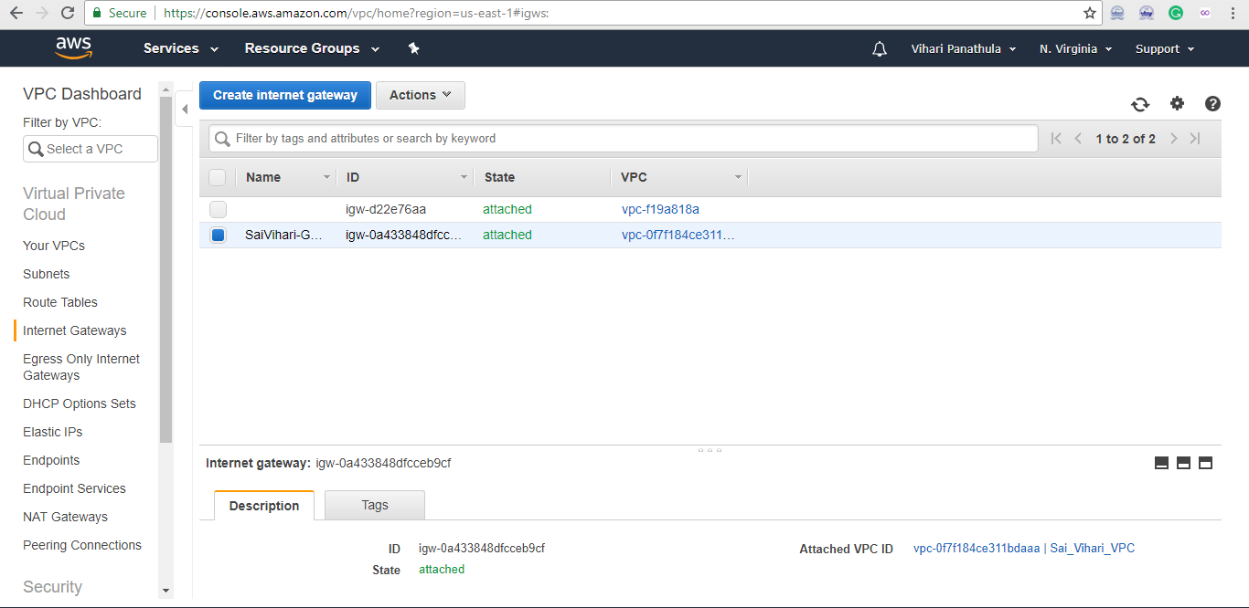

* Click on **create internet gateway** and assign a name to it and save .
* Click on **Actions** button then Assign VPC for the internet gateway.

**Step-10:** Create the route tables

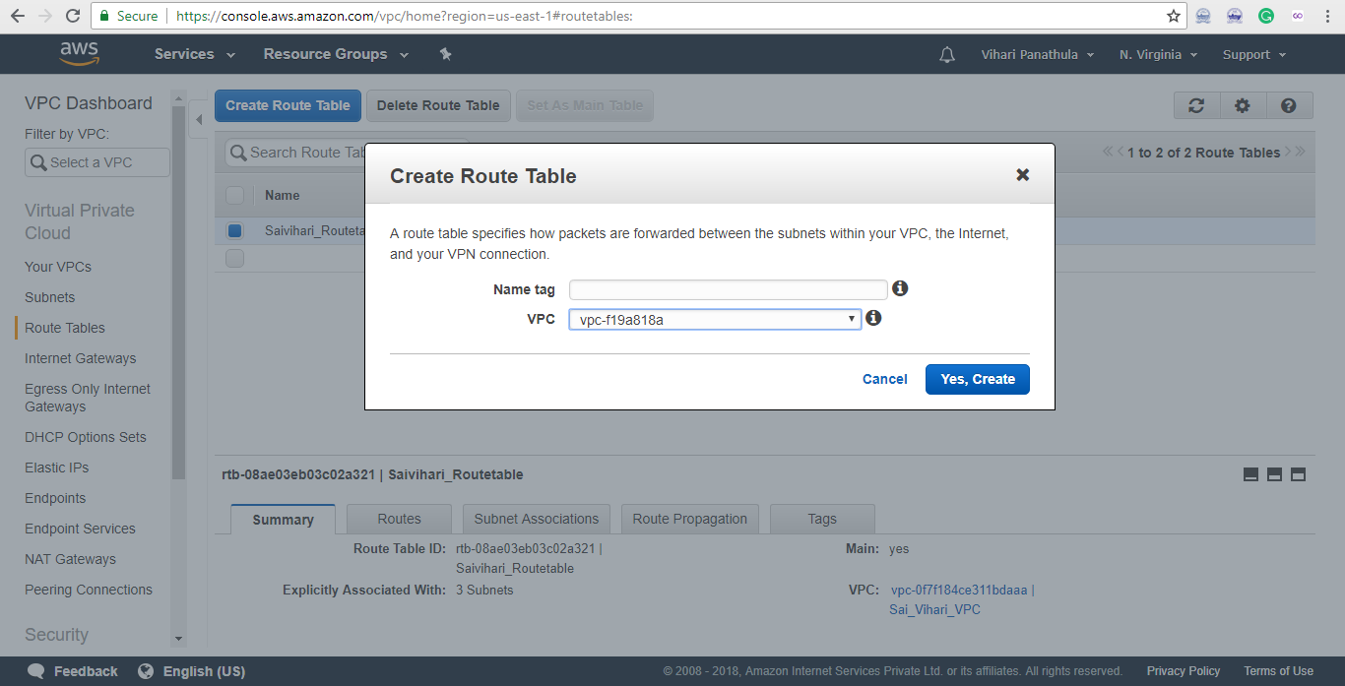

* Create a **name tag** .
* **Assign** the VPC which you have created.

**Step-11:** Click on the **Routes** and assign as in the picture below.

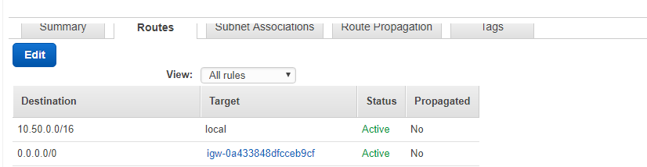

**Step-12 :** Click on the **Subnet Associations** and associate all the subnets which ever you are created before in the subnet creation module.

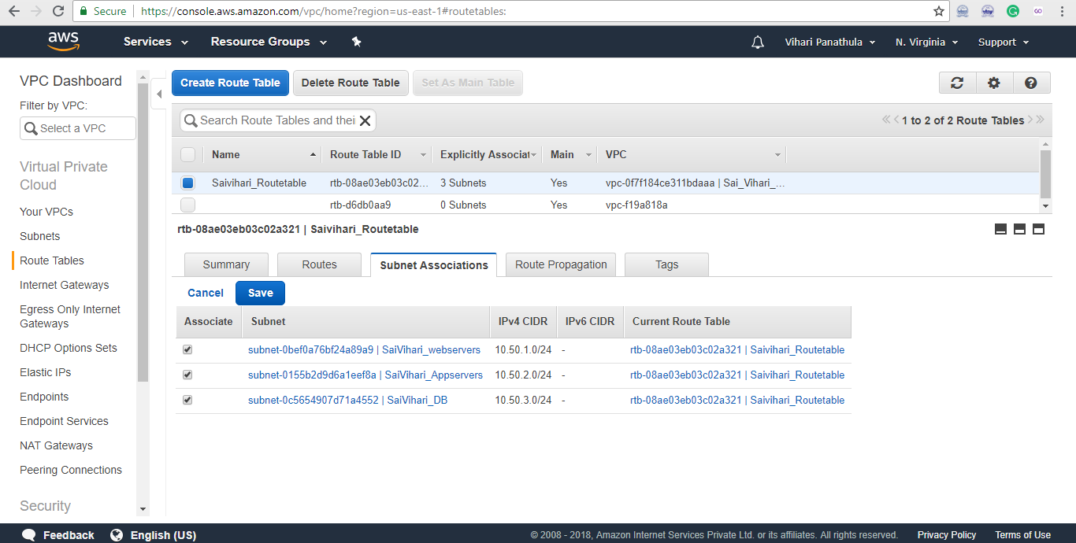

**Step-13 :** Go to **EC2 dashboard** and lauch the instances as usual (Changes shown in the figure while creating the instance)

**Changes-1:**  In the Network module, we already created the VPC so click on that.

**Changes-2 :** In the Subnet module , we have already created subnets so for each instance click on one subnet which ever we need.

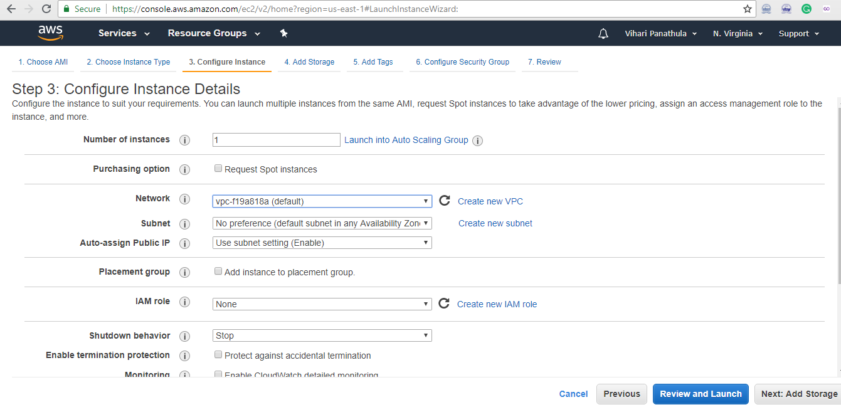

**Step-14:** Create a new security group

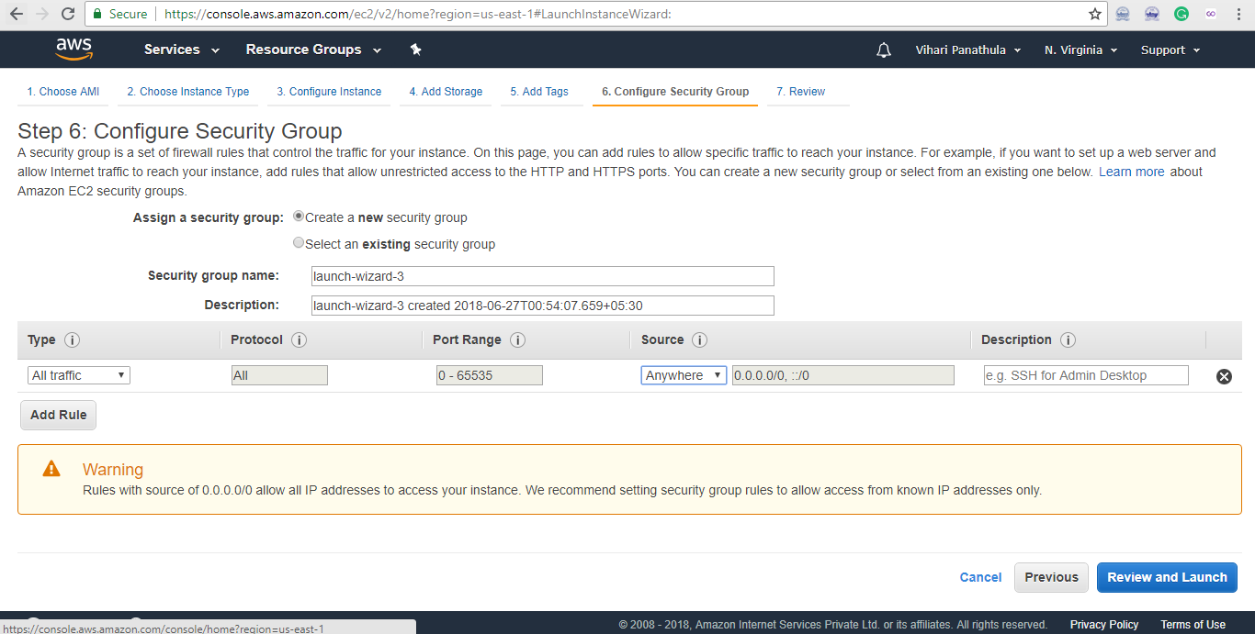

**Finally launch the instance**

**Step- 15:** Like wise we have to **create remaining 2 instances** with different subnets.

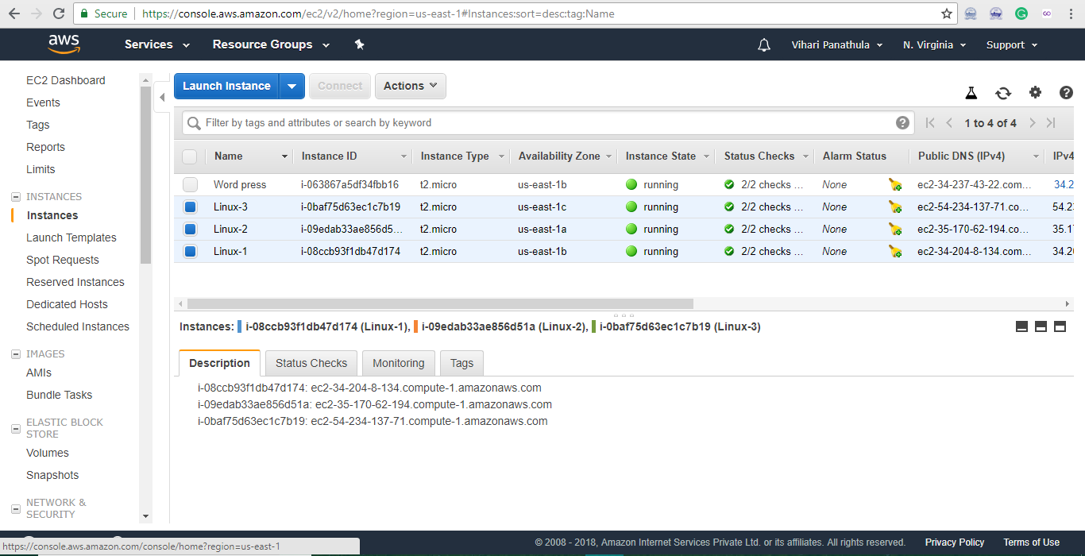

**3 Instances connected with the VPC**

**WordPress:** In this WordPress we have to just create the username and password by using the amazon web services and then we can design the website by install plugins and themes.

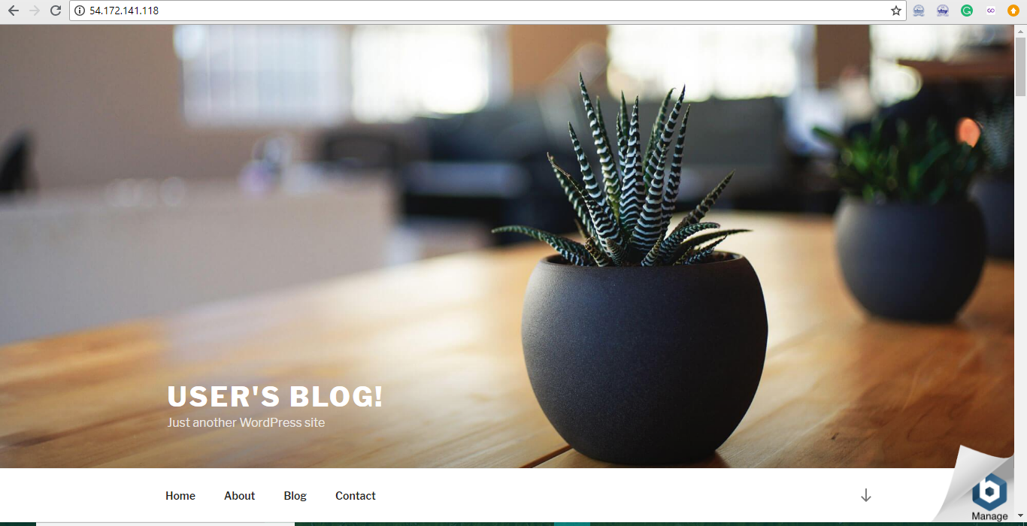

**SIGNIFICANCE OF WORK:**

**Description:**

One way of getting other websites to link to you and spread the word about your business is to create our own WordPress websites by using the Amazon web services.

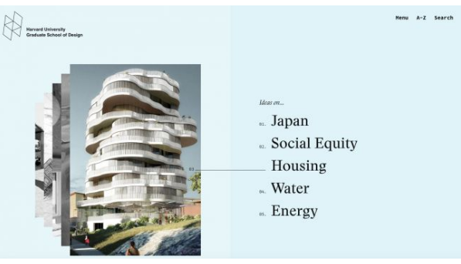

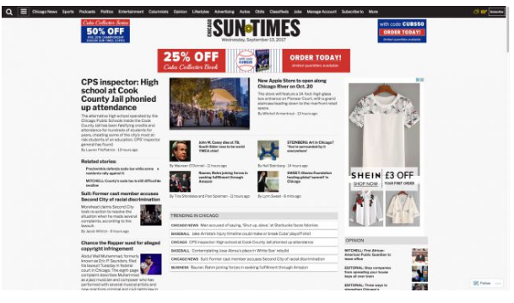

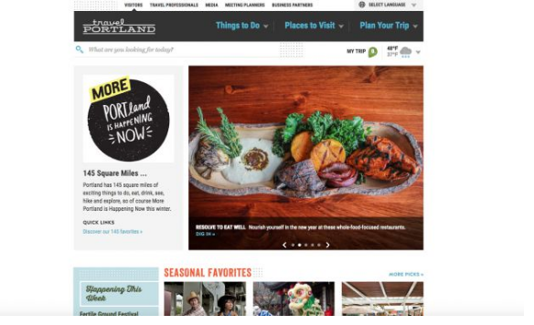

These are some examples of the WordPress websites.

**RESULTS AND DISCUSSIONS**

**Percentage of WordPress users:**

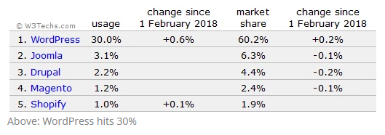

Now that we know the pros and cons of both WordPress and HTML websites. Let’s talk about which one is better for your business website. If you are certain that you will never want to update, change, or add anything new to your website, then by all means go for a HTML website. It will be faster and will serve your purpose.

If you want to have the freedom and control of your website and not waste money on monthly retainers paying developers to add images, then WordPress is obviously the better choice. For those who want grow their business website to make you more money, then WordPress is the way to go forward. Using WordPress you can add content to your website without hiring anyone. You can create as many pages as you need at any time. You can add a blog section to keep your customers updated, or even build your own email list and keep bringing more customers to your business. You will be part of a global community of businesses using WordPress to manage their online presence. You will find plenty of free help, resources, tools and plugins to grow your business every day. Instead of paying developers loads of money for smallest things, you will be able to spend that money on growing your business with WordPress.

**Results of the project with Screenshots:**

Here I have implemented the WordPress website in the Amazon web services. Some of the screen shots are presented below.

**Amazon RDS:** In the below screenshot I have to choose an engine for our website.

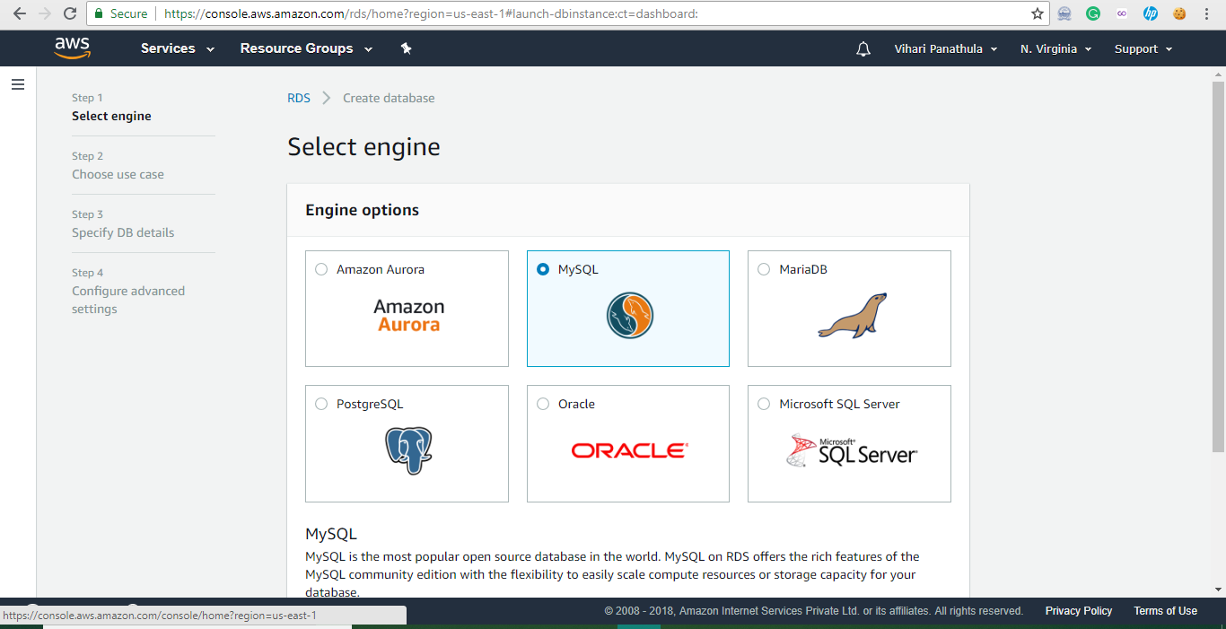

Here I am configuring the DB settings.

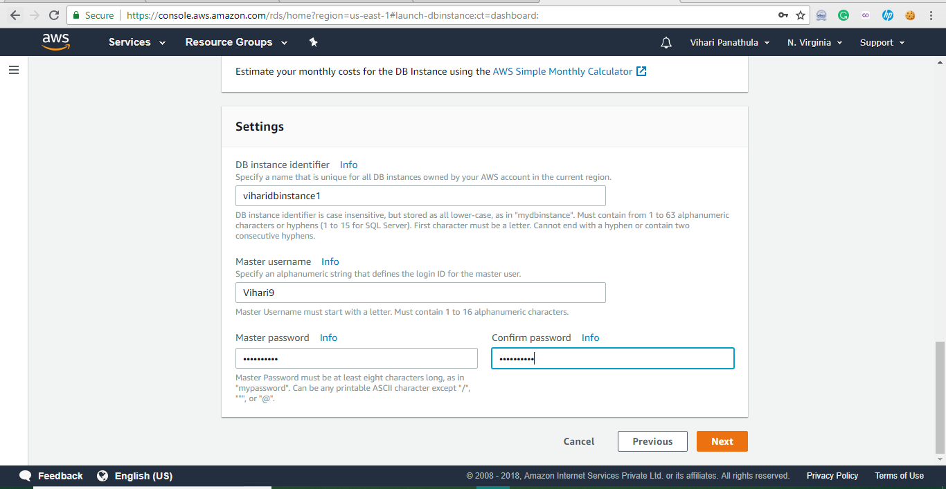

Here I have launched the Database instance in Amazon RDS.



**Security Groups:** Choosing the security group in the Instance.



**Elastic Beanstalk:** Creating the elastic beanstalk environment.



**Amazon S3:** Creation on bucket in Amazon S3

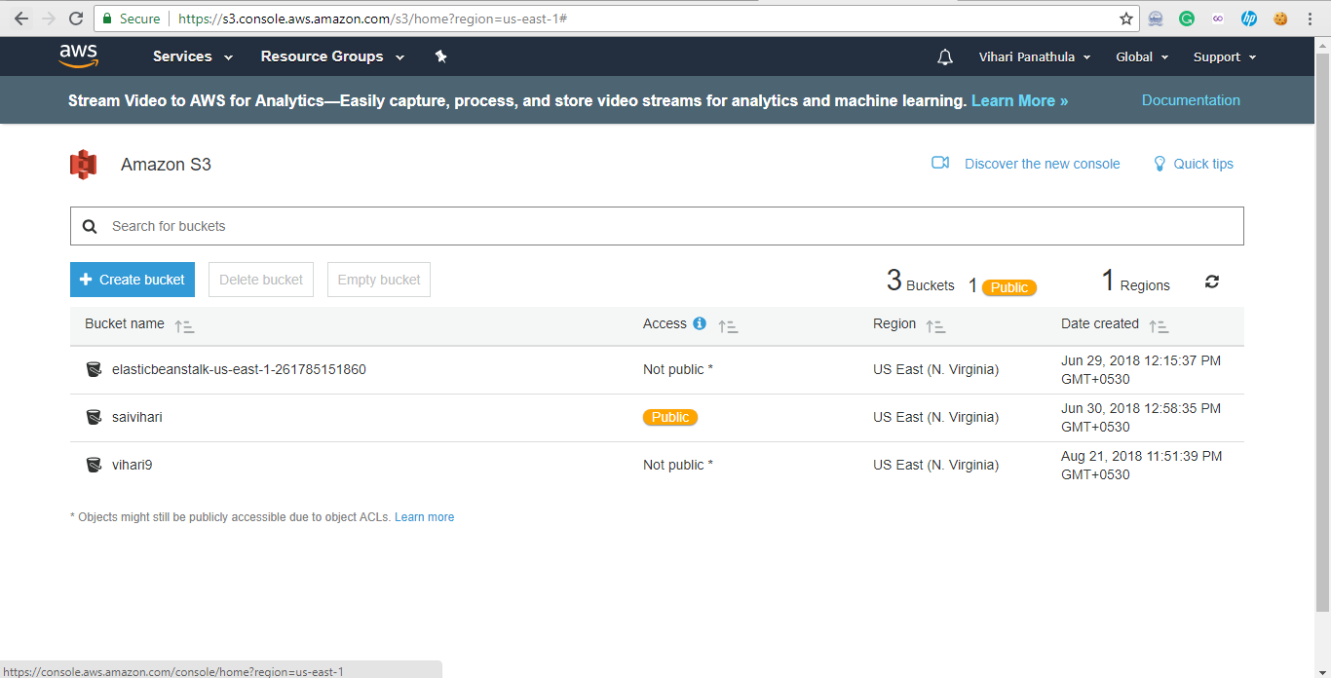

**WordPress:** If you’re a massive corporate brand with a big marketing budget, hiring a design firm to build a custom website for your company will make sense.

WordPress, however, is best for small businesses who are starting up. Because it’s affordable and so easy to setup that even someone without any web design knowledge can build a website.

Successfully launched the WordPress website in the Amazon Web Services.



Creation of username and password

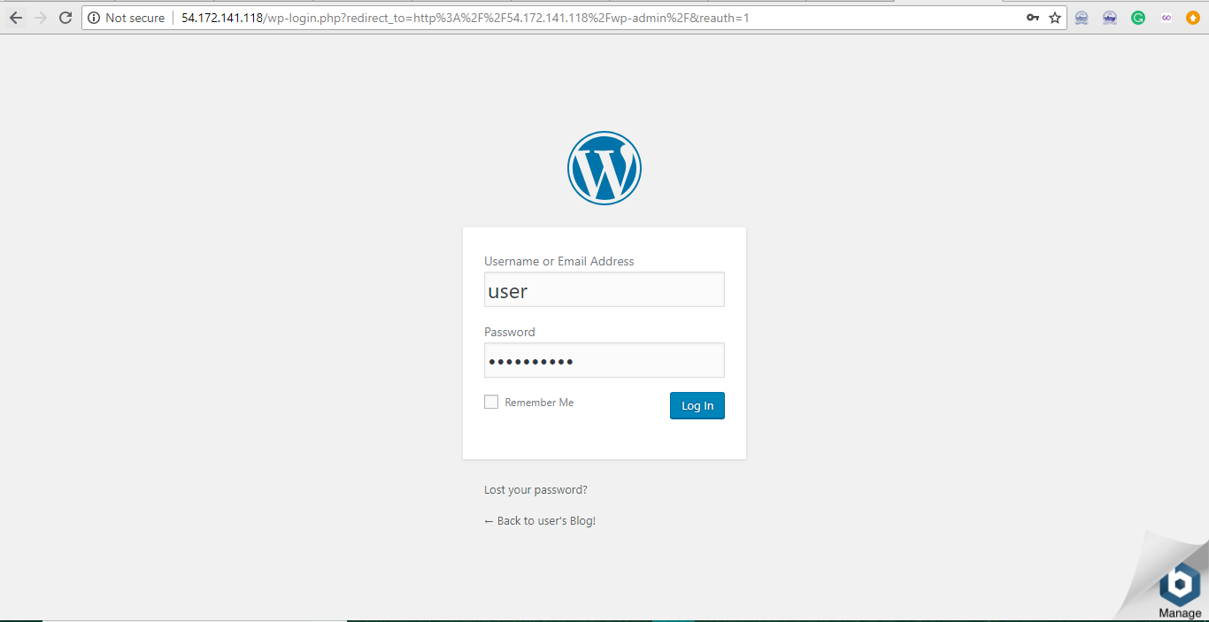

Finally Installing the Themes and Plugins of the Website.

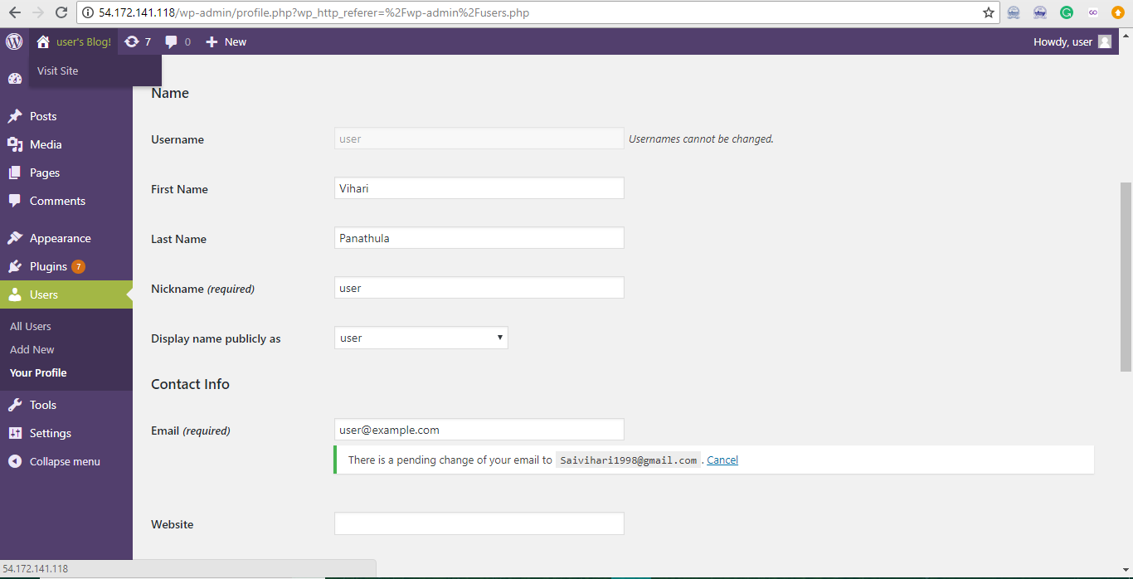

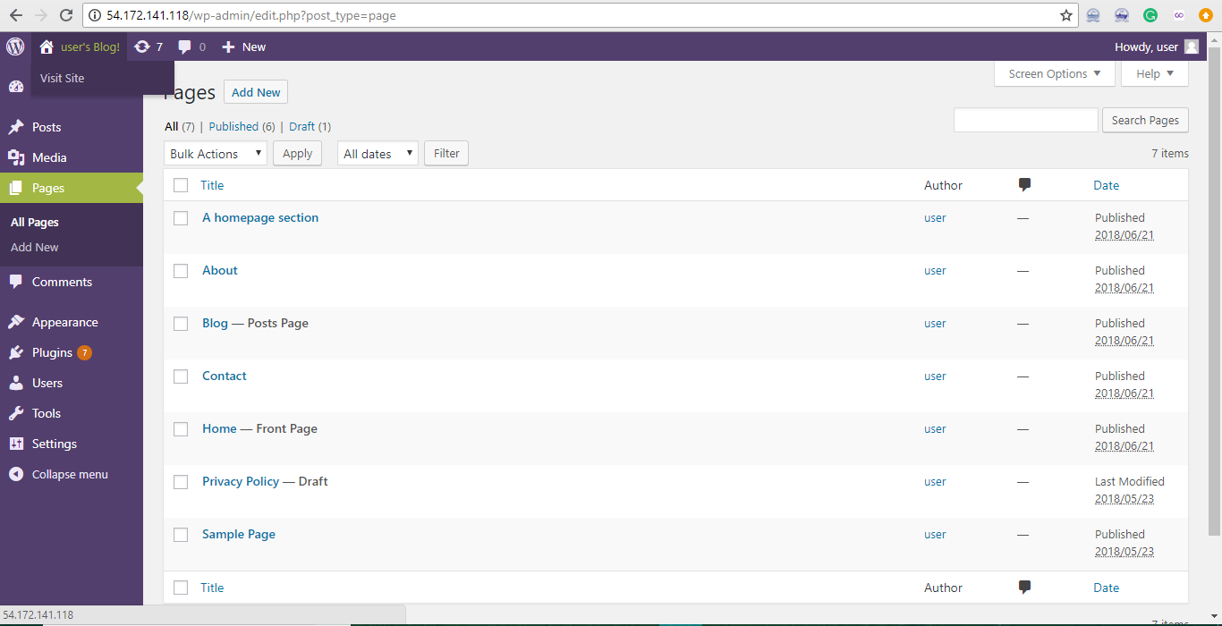

**CONCLUSION AND FUTURE WORK**

**7.1 Conclusion:**

Here, I conclude that AWS is the best platform to deploy the applications easily and faster and one main thing to use the use the AWS is we don’t have to manage all the server side things, totally under control in the Amazon web services even the Security issues reduced by the Cloud security in Amazon web services platform. We can access the website where ever we are in the World. We can easily host the WordPress website in the AWS.

In world population 40% of the companies are using the WordPress websites because it is easy to use and User Friendly. Pre maintained templates are available in the Internet we can just download the templates which ever we want and add the template to your website and make a good design. Likewise we can easily made our website and host it in Amazon web services.

Finally, Make use of WordPress websites and save time and cost.

**7.2 Future Work:**

Here, I am concluding my future work about my project is to get more and more security to the WordPress website which ever creating by us and mainly I’ll try to improve the hosting free in the amazon Web services Because Amazon web services is the pay as per use model it will cost much for the hosting (but not more than private hosting websites such as Go daddy, Hostgator etc.).

Main thing improve in this system is to attach with any recognition systems to maintain more security to the website. By maintaining this security we won’t affect for hacking anymore.

**REFERENCES**

1.https://docs.aws.amazon.com/elasticbeanstalk/latest/dg/php-hawordpress-tutorial.html?refid=gs_card. (12th June 2018)

2.https://aws.amazon.com/getting-started/tutorials/launch-a-wordpress-website/.(15th June 2018)